**STUDY GUIDE ROUND 2**

**Quantile** = (xi + x(i +1) )/2 Roughly, **a q-quantile** of the data x1, . . . , xn is the smallest number greater than or equal to 100q percent of the values in the data.

**A p-percentile** is the smallest number that’s greater than or equal to p percent of the values in the data (i.e. p-percentile = (p/100)-quantile).

**IQR** = .75 quantile -..25 quantile

**Conditional Probability**

**Sample space**= S=the set of possible outcomes & **Events** = any subset of outcomes contained in a sample space





The number of ways to k sized groups from a tot. of n things.

1. with replacement, and order matters, is n^k;

2. without replacement order matters,

3. without replacement, and order doesn’t matter, **Conditional**



**Random Variable**



**Discrete:** random variable is an rv whose possible values either constitute a finite set or else can be listed in an infinite sequence in which there is a first element, a second element, and so on (“countably” infinite).

**



Since the PMF is symmetric around the origin, it follows that the expectation is zero because the positive and negative parts of x cancel.

**Expected**



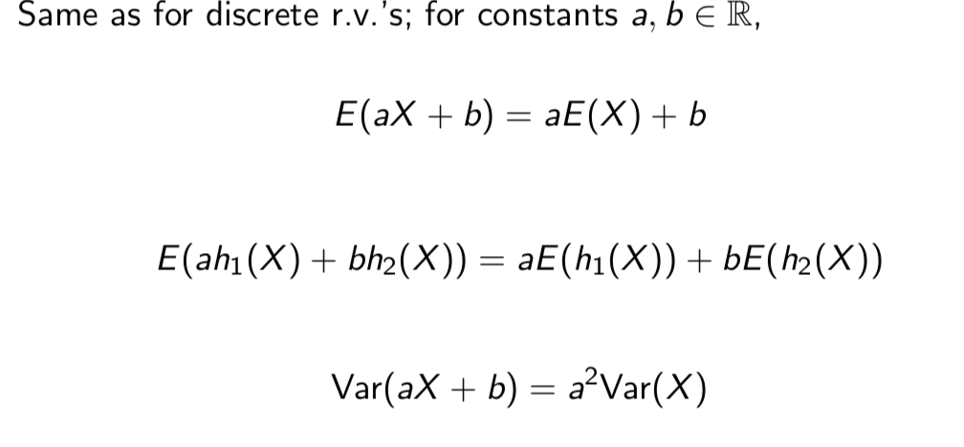  



**Binomial----------------------**

**

**Poisson----------------------**

can be used to model the number of times that an event occurs during a fixed length of time when:

**1.** The probability that an event occurs during a given interval is proportional to the length of that interval.

**2.** The occurrence of an event doesn’t change the probability that another will occur.

**3.** Two events cannot occur at exactly the same time.

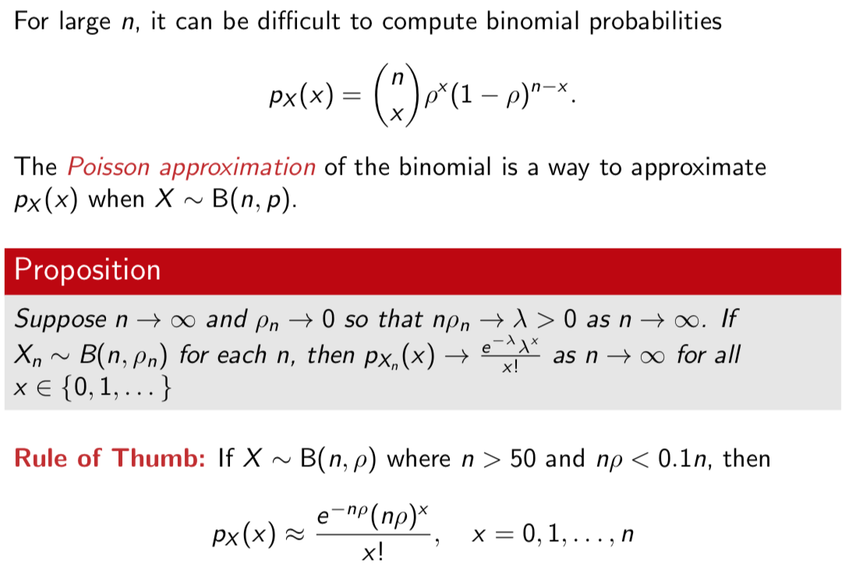

**Continuous RV-**

**Uniform ----------------------**

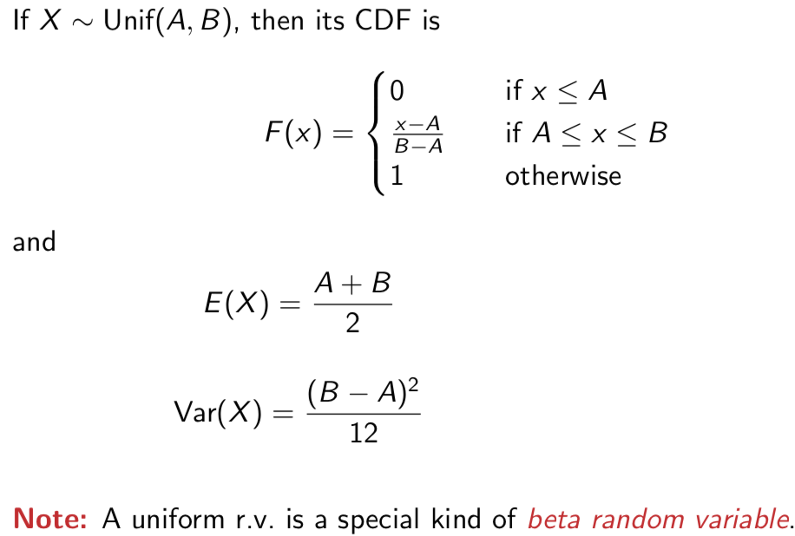 **Percentile ----------------------**



**Normal Distribution**

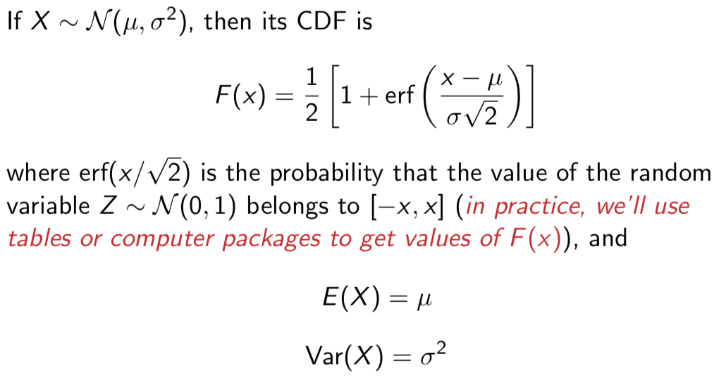

**Binomial Approx--------------------------------**

**Exponential----------------------**



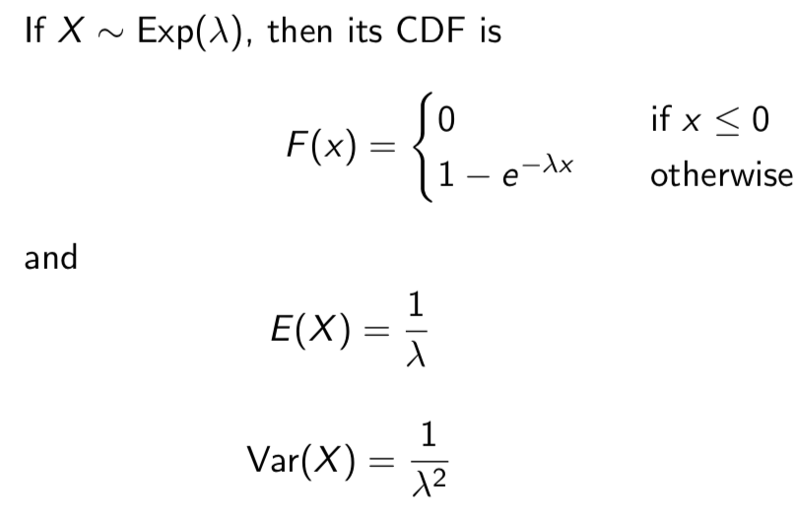

**Gamma----------------------**





**Weibull----------------------**

**Hypergeometric R.V.: #** of successes when sampling without replacement

**Binomial R.V.: #** model binary data, of successes when performing a number of Bernoulli trials

**Poisson r.v.’s model** the number of events (e.g., customer arrivals) that occur during some fixed time interval. model count data,

**Geometric r.v.’s model** the number of Bernoullitrials needed until the first “success”.

**Uniform r.v.’s:** when any number in a range is ] equally likely with the same probability

**Exponential r.v.’s**: useful for modeling waiting & interarrival times

**Normal r.v.’s:** most widely used

**Weibull r.v.’s:** generalization of exponential r.v.’s; useful for reliability theory

**Gamma r.v.’s:** generalization of exponential r.v.’s; useful for sums of exponential r.v.’s

**Beta r.v.’s:** generalization of uniform r.v.’s; useful for modeling r.v.’s whose set of possible values is a finite interval

-------------------------------------------------

P(A∪B∪C) attains its **maximum**  ifA, B, and C are disjoint. In this case, P(A∪B∪C) = P(A)+P(B)+P(C) = 0.35+0.3+0.1 = 0.75. On the other hand, P(A∪B∪C) attains its minimum if A contains B, which in turn contains C. In this case, P (A ∪ B ∪ C) = P (A) = 0.35.

P(x<T ≤x+1)=P(T ≤x+1)−P(T ≤x)=(1−P(T >x+1))−(1−P(T >x))

P(b) = P(b/a) + P ( b/ not a)

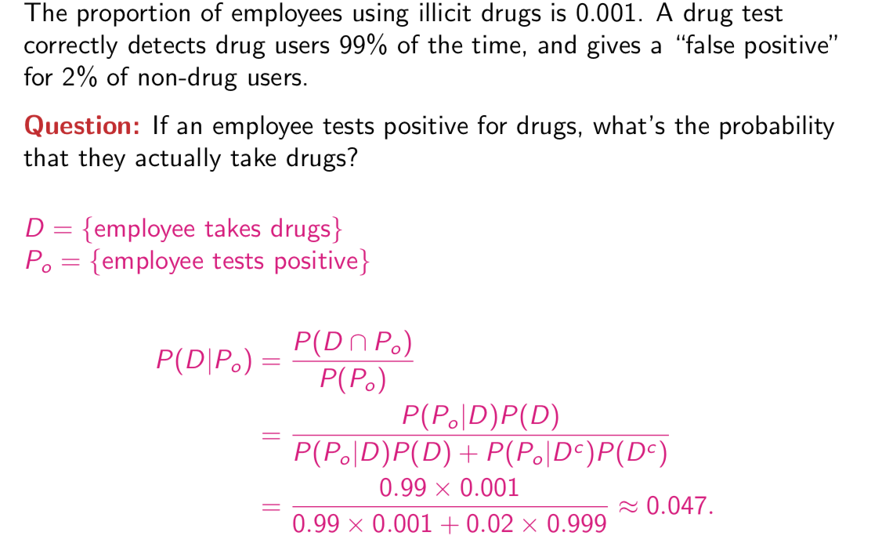

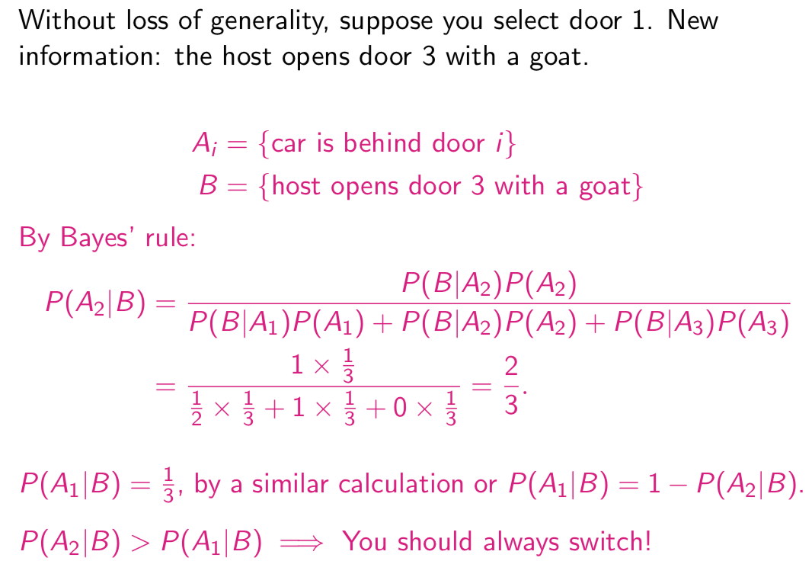**-** If A and B are mutually exclusive, must they be independent?-No

**-** If A and B are independent, must they be mutually exclusive?-No

**Beta**

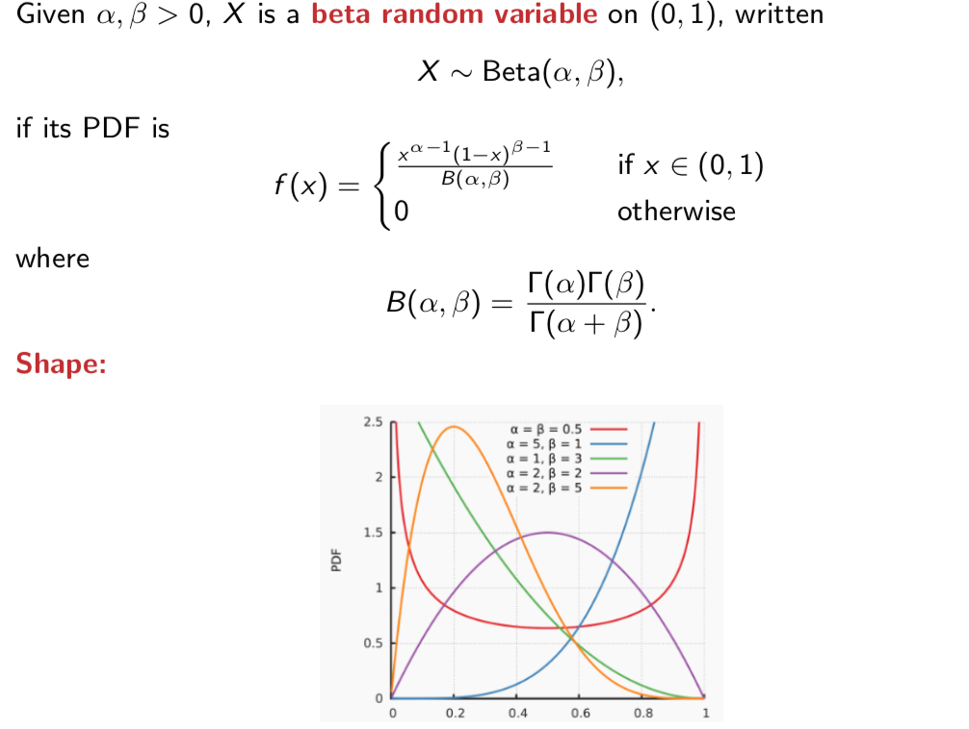

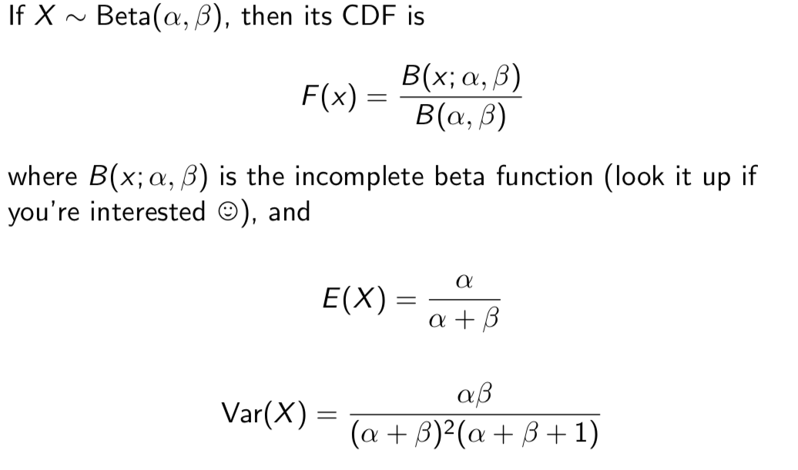

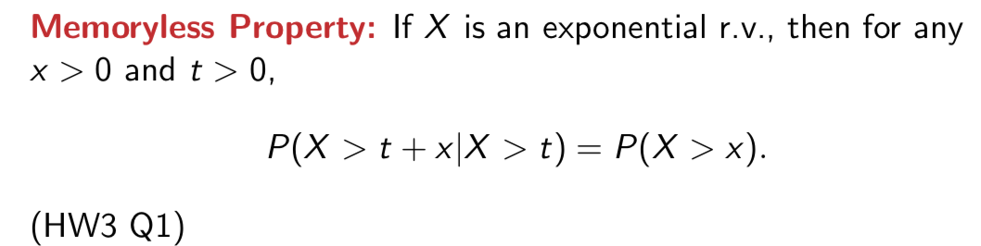

**Geomertic**

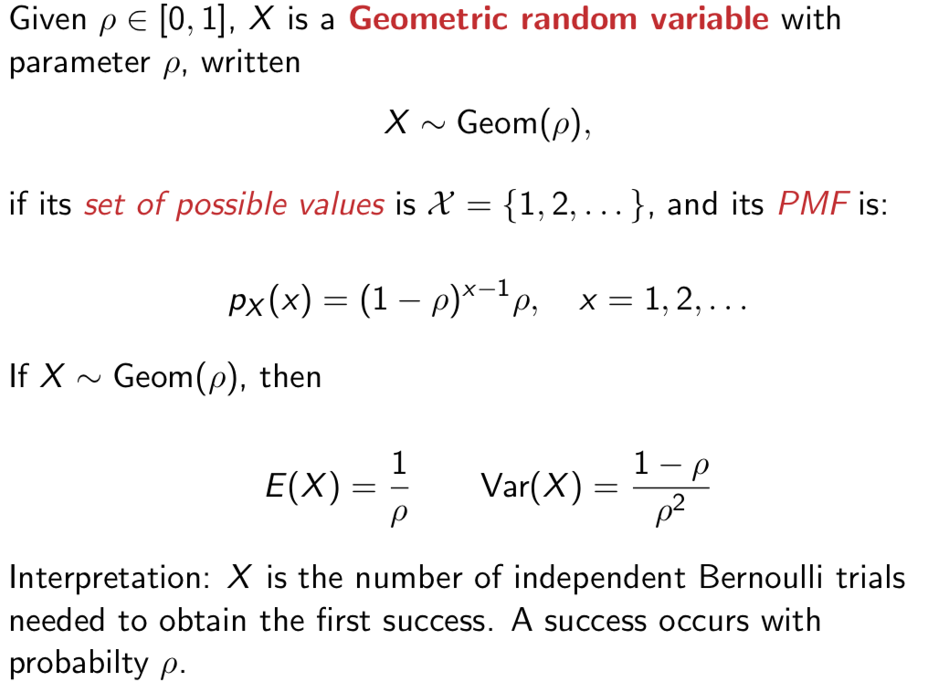

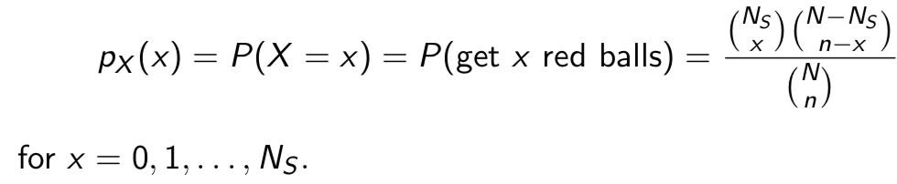

**Hypergeometric RV**

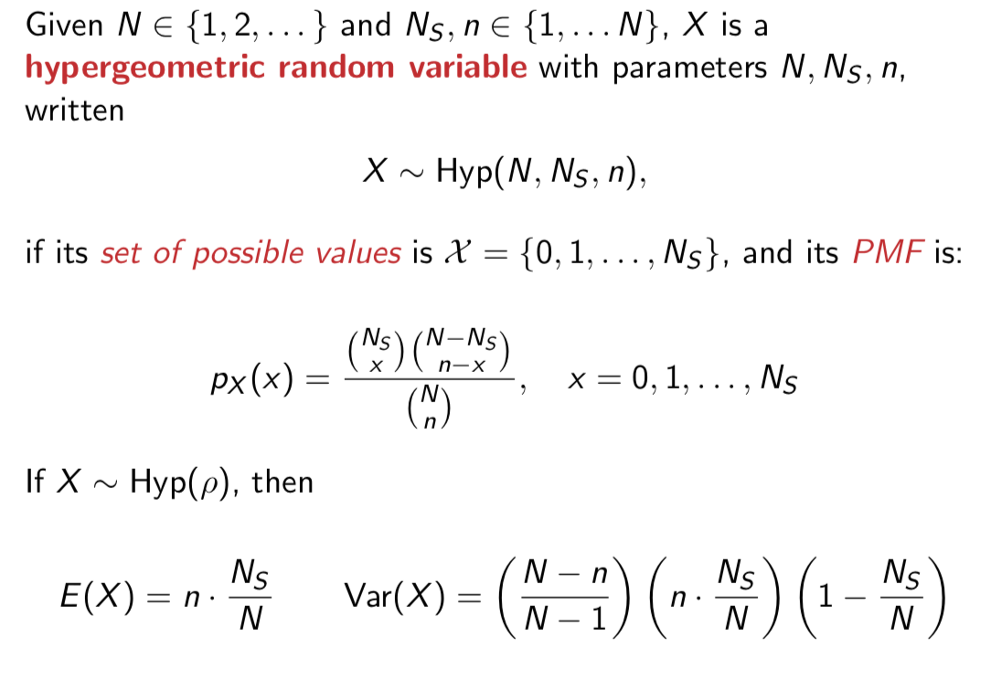

E[Y] = E[2X +3] = 2E[X]+3

Var(2X +3) = 22Var(X) P(4≤X ≤9)=P(X ≤9)−P(X ≤3

